Holy Trinity Church
446 Hamilton St., Southbridge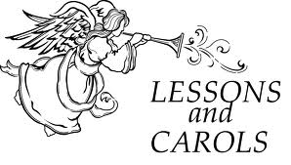
9:30 Sunday, December 28th
CANDLELIT LESSONS AND CAROLS
With Holy Eucharist
Come:
Listen to lessons /stories that tell of Christ’s birth.
Sing Carols that celebrate the birth of Christ.
Join us for hospitality in the parish hall afterwards

